What time is it?

Name: ____________________________________________________________________

Write the correct times according to the pictures below:

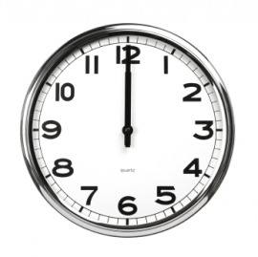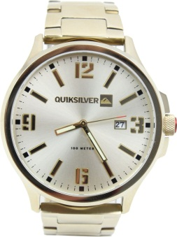

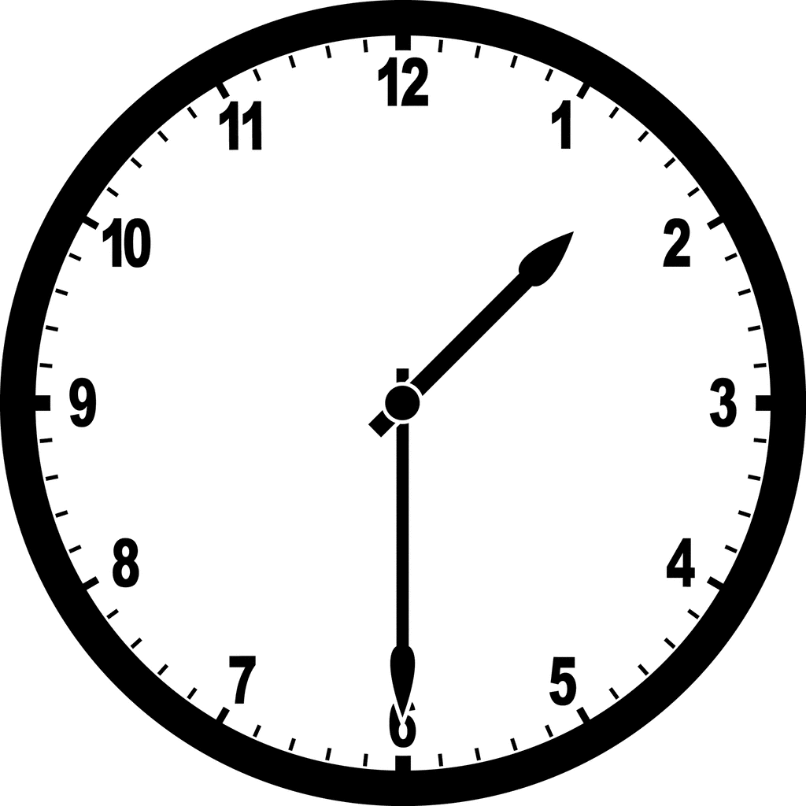

_________________________ _________________________ _________________________

_________________________ _________________________ _________________________

_________________________ _________________________ _________________________

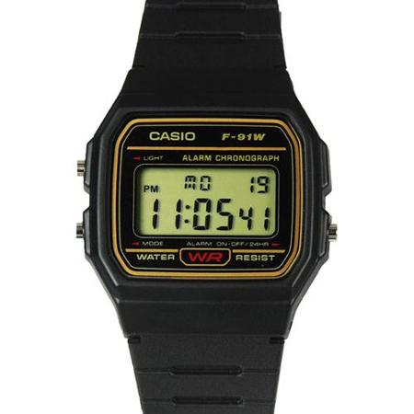

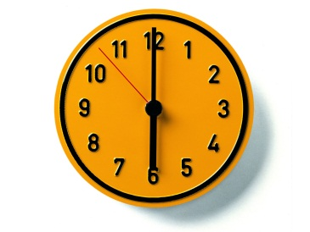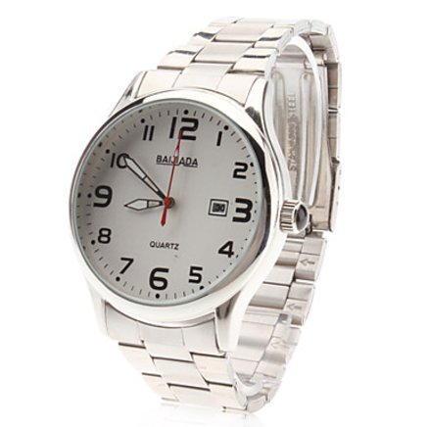

_________________________ _________________________ _________________________

_________________________ _________________________ _________________________

_________________________ _________________________ _________________________

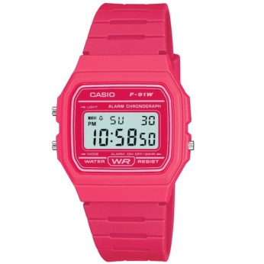

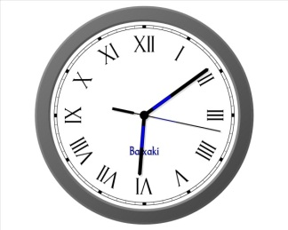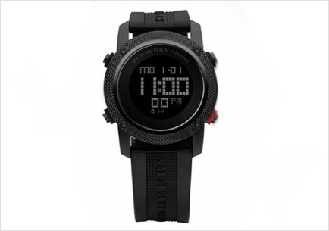

_________________________ _________________________ _________________________

_________________________ _________________________ _________________________

_________________________ _________________________ _________________________

What time is it? (sheet2)

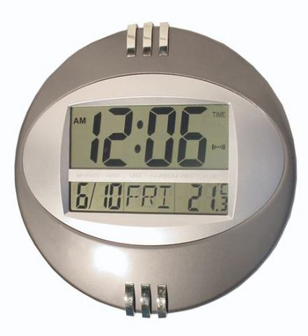

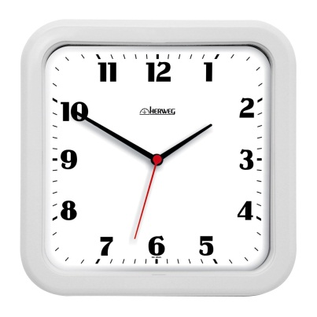

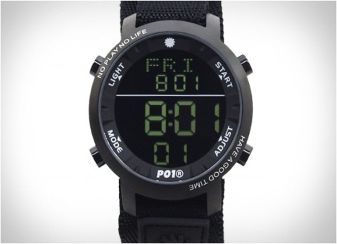

_________________________ _________________________ _________________________

_________________________ _________________________ _________________________

_________________________ _________________________ _________________________

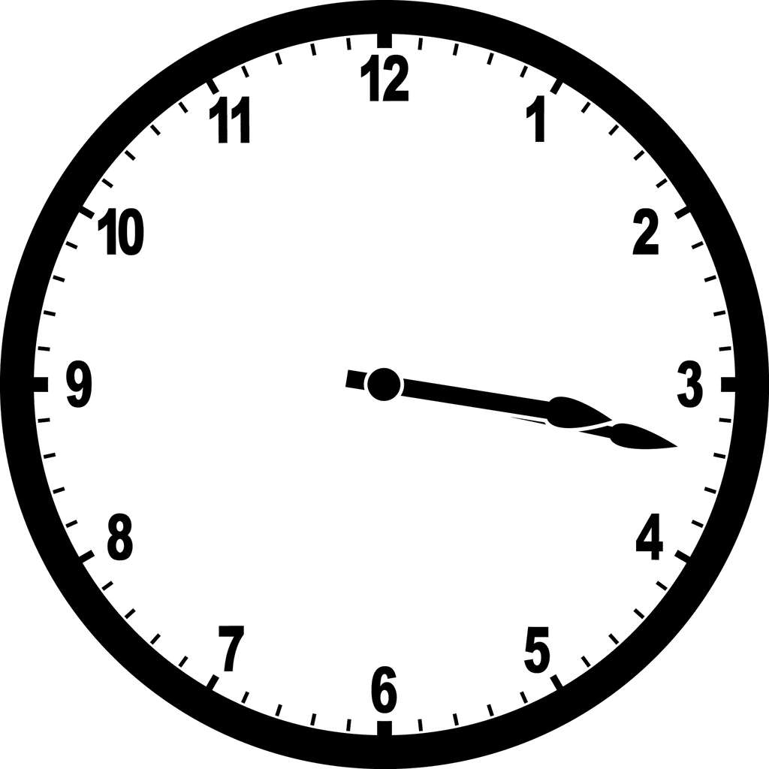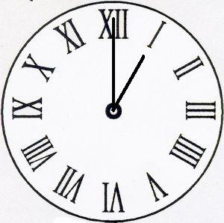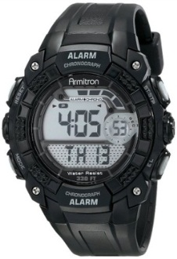

_________________________ _________________________ _________________________

_________________________ _________________________ _________________________

_________________________ _________________________ _________________________

Do it yourself now! Draw the pointers and write the times below:



  

  

  